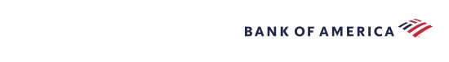
Be the generation to serve, inspire and change the world
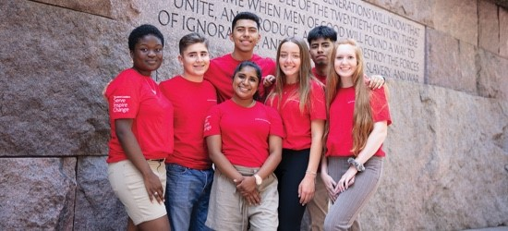
Through Student Leaders®, Bank of America recognizes high school students who lead and serve in their own communities and beyond. We connect Student Leaders to tools and resources to help make communities better.
As a Student Leader, you'll:
Current Juniors
and

Seniors:
Apply from
October

17
,

2022
–
January

13
,

2023
Work as a paid intern at a local nonprofit for eight weeks
Attend the weeklong Student
Leaders Summit in
Washington, D.C.*
Develop leadership and career skills
Connect with like‑minded students from your own community and across the country
Visit our Student Leaders page for more information.
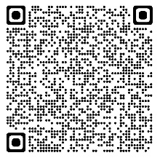
* In-person events will be in line with local and national guidelines for gatherings and travel and may be subject to change.
©2022 Bank of America Corporation. Member FDIC. EMAIL‑08‑22‑0373 MAP4918777

